NEWSLETTER

No. 02, Term 02, Week 03

Monday 14 May 2018

Greetings, Kia ora, Talofa lava, Kia orana, Malo e lelei, Fakalofa Lahi Atu, Namaste, An Young Haseyo, Konichiwha, Bula Vinaka, Sawadee, Dobra Dan, Ni Hao, As-salamu alaykum, Hola

From the Principal – Mrs. Watts

We are 3 weeks into term 2 already. Time has flown by so quickly. Our fortnightly newsletter is full of information and upcoming events. Our inquiry focus this term is on inventions and innovators.

Baking Programme
Baking Programme: Both children and parents are involved with this. We are looking to bake food from other ethnic groups. We’d love if you could help us with this. Please let us know if you can.

ASB Banking
We can now offer school banking. Banking day is on Friday. Forms are located on the Kashin the Elephant bank deposit box in our reception area. When children sign up to open an ASB account, they will be sent a Kashin deposit box and calculator in a yellow bag - all to keep. If you’d like to register your child for free, for this, please see our friendly office staff.
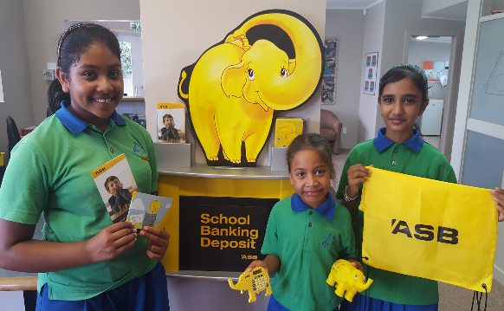

Winning House
Congratulations to KOWHAI house on your win last week.
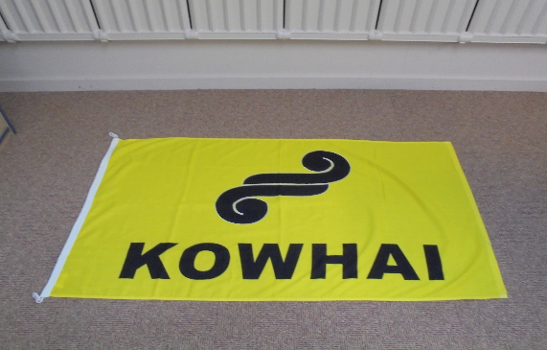

NEXT WEEK: MOTAT TRIP
Maungarei Team (Rooms 3, 5 and 7) - Wednesday 23 May

Te Kai a Hiku Team (Rooms 1 and 2) - Friday 25th May

Please pay $12 to the classroom teacher or school office before this date.

TE KAI A HIKU TEAM
(Junior School Rooms 1 and 2)

Room 2
It’s great seeing parents pick up their children after school and having an informal chat with Mrs Kumar about their child’s learning. I know she’s enjoyed meeting and speaking with parents.
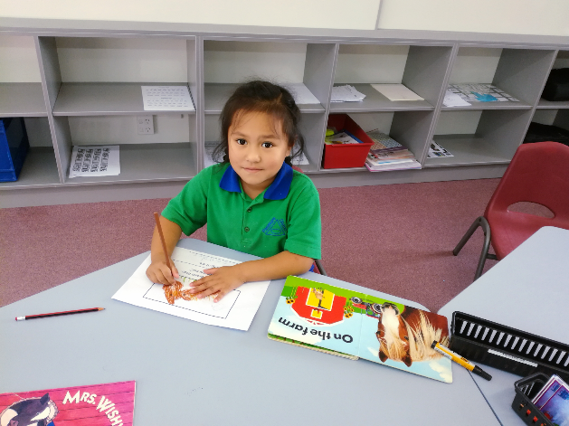

Play based learning
Rooms 1 and 2 are enjoying their Play Based learning held twice a week in Room 4. Here are some Room 1 students in the construction area.
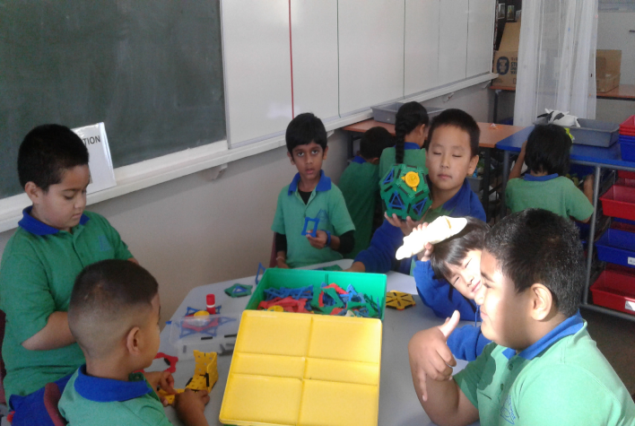

Term 2 upcoming dates
Tamaki Cluster Football for Year 5/6 and Year 7/8

Dental Van visit in week 04. If any parent have some other concern regarding their child’s teeth please send a note to the class teacher and it will be given to the dentist for check-up.

Auckland University Optometry eye testing on 24 May in the school hall.

Keeping ourselves safe (Police Visit)

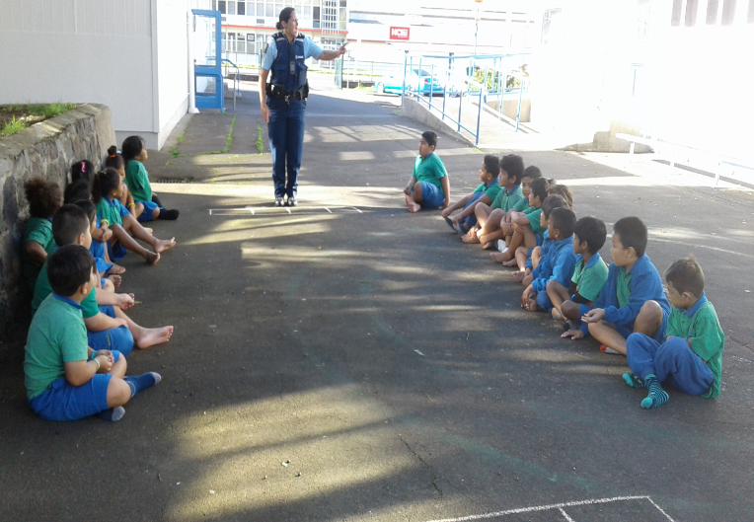

On Monday, Tuesday and Wednesday last week, Constable Taina Karaka came to talk to Rooms 1 and 2 about Road Safety and Keeping Safe. The children enjoyed learning with Constable Taina.

Temple Visit
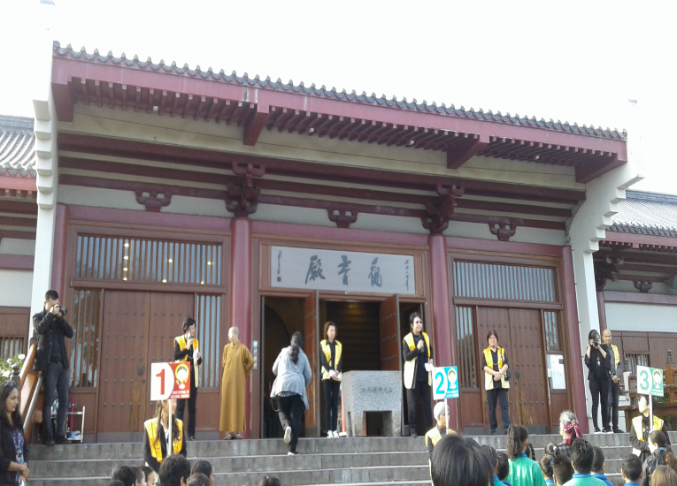

Last Thursday, our school went to visit a Buddhist Temple in Botany. We learnt about sharing and diversity.

Sailing
20 children from Rooms 5 and 7 went sailing. They were sponsored by the Lion Foundation. All the children had a great time and loved the experience.

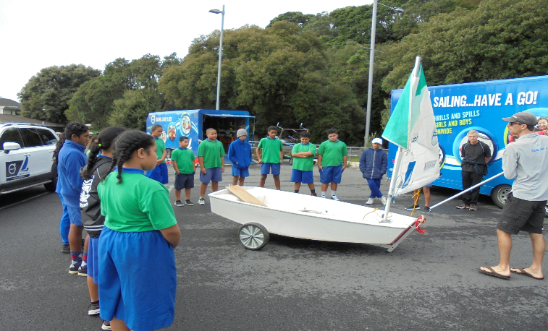

Sailing Trip
It was the start of a beautiful morning. The sun was shining upon our heads gazing down at us. We walked through Okahu Bay with excitement hoping this day will be fun.
We all walked politely to our instructors glaring at the boats that were scattered around the premises. We all were focused on watching our instructor show us how to build a boat. Everyone struggled but ended up finishing with a strong boat.
Sometime after that they gave us a swimsuit that was so tight to put on. It felt like you were a penguin trying to breathe. We had a short break a while after, then we got straight into sailing in our own boats with our buddies.
As we sailed through the rough tide the wind was howling giving me goose bumps as I was gliding through the wind. The smell of the salty water was surrounding us and the waves are pushing us further and further out of shore.
Everyone was getting competitive on trying to win the games we played. Some people would jump out of the boat, the taste of the salty water was disgusting making me sick. As the day ended although very exhausted and ready to faint, we were very happy. We all had a great experience and we all hope to have this day come again.

By Haley Pawhau Y8 Room 7

Merit Awards
Room 01 -
Elijah Kaisa for his hard work in Reading and Maths.
Manatu Tupou for her excellent Reading and great improvement in Writing and Maths.

Room 02 -
Faatili Tongia for instantly recalling most “RED” words.
Tinkle Dang for working diligently on all set tasks.

Room 03 -
Marshall Hepana for making all effort to complete his reading tasks.
Januth Gamage for settling into his new school and being involved in building friendship.

Room 05 –
Sosaia Ofakineiafu for participating in all aspects of school life.
Brooklyn Taufa for showing initiative with his learning.

Room 07 –
Hazel Godoy for showing independence and perseverance in her work.
Krrish Narayan for showing manners and having a respectful attitude.

Duffy Awards –
Zion Naivaluvou Leandra Lim
Kierstian Idago Rebekah Cabada

